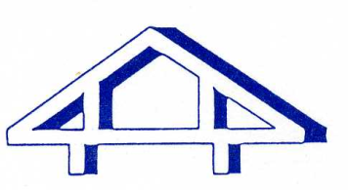
Darley Dale Medical Centre

Patient Participation Group

Minutes of the meeting held on: Tuesday 28th March 2017

List of attendees:-

Dr Ed Oakley Gwendolyn Green
Melissa Smith (Practice Co-ordinator) Peter Woolhouse
Iris Wagstaffe Rosemarie Barber
Shirley Davison

Apologies: Robert Hamilton, Sally Botham, James Macfarlane, Norman Rimmell

Agenda Items

East Midlands PPG Awareness Event – Research Projects
A member of the PPG attended the awareness event, and although was unfortunately not able to attend the meeting to discuss the outcomes, provided a detailed account. Copies of this report will be made available at the next scheduled meeting. Members of the group enquired as to current and potential research projects that the practice may be involved in, and Dr Ed Oakley explained the following initiatives:
- Weekly MDT (multi-disciplinary team) meetings – these are held at the practice where representatives from other care organisations such as CPN/CMHT/adult care/social care attend to discuss patient cases and ensure improved connections between health providers.
- CANDID study – the practice is currently engaged in this research study which aims to find out which symptoms and tests are best for predicting cancer diagnoses.
- FAST study – the practice is currently engaged in this research study which aims to find out whether a particular medication item is safer than an alternative for long term use in patients with gout.

Current Government Initiatives
Dr Ed Oakley explained that initiatives which affect our practice and local area are mostly individual cases which are initiated by our CCG (Clinical Commissioning Group). He went on to say that this sometimes results in cuts to services, for example the decommissioning of gluten free products being provided on NHS prescriptions. Dr Ed Oakley then explained that initiatives can also be decided by local groups or committees, for example the recommendation of monthly prescribing which was discussed by the JAPC (Joint Area Prescribing Committee).

AOB
The PPG group discussed the possibility of holding an open day or health promotion event upon the completion of the new surgery being built. Dr Ed Oakley advised that he would discuss this with his partners and provide an update at the next scheduled meeting.

